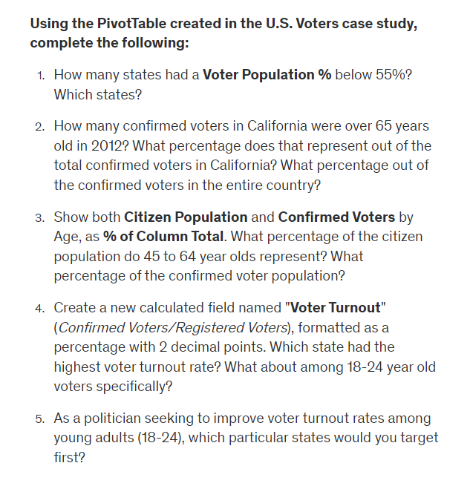

1. Texas, Arkansas, Oklahoma, Hawaii, West Virginia  
     
   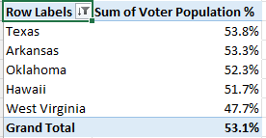

2. California, 21.56%, 2.18%

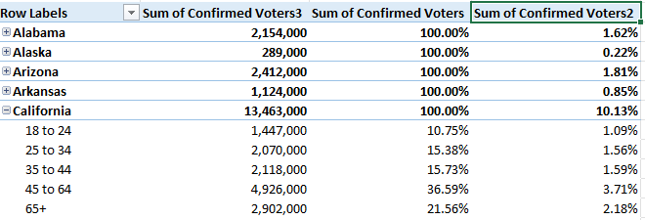

3. 35.63%, 39.12%

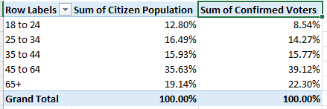

4. Colorado 94.69%, Wisconsin 93.18%

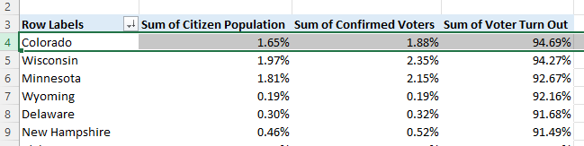

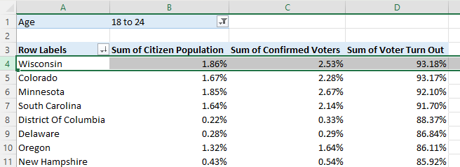

5. West Virginia, Arkansas, Texas, South Dakota, Montana

